Question Bank Module 4.

1. Write and explain the functions of Warshall’s and Floyd’s algorithm.
2. Apply Warshall’s algorithm to find the transitive closure of the digraph defined by the following adjacency matrix:

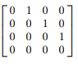

1. a. Prove that the time efficiency of Warshall’s algorithm is cubic.
2. Solve the all-pairs shortest-path problem for the digraph with the following weight matrix:

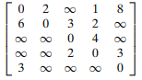

1. a. Apply the bottom-up dynamic programming algorithm to the following instance of the knapsack problem:

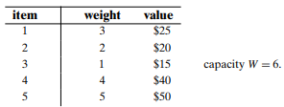

1. Explain the concept of dynamic programming and what is the advantage of dynamic programming over recursive algorithms. Give some examples.
2. Write the algorithm of knapsack problem for dynamic programming. Solve the following instance for the knapsack problem.

Items =4

{W1,w2,w3,w4}= {2,1,3,2}

{p1,p2,p3,p4}={12,10,20,15} Capacity=5

1. Write floyd’s algorithm and solve all pairs shortest path problem for the following graph.

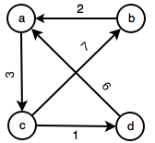

1. Write Warshall’s algorithm and find transitive closure for the following graph.

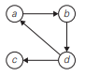

1. Write Binomial Co-efficient algorithm and find Binomial Co-efficient for the following for the value C=6, k=4 using dynamic programming.
2. Calculate the time efficiency Binomial Co-efficient.